**Practical 8 – Cassandra**

**CQL offers a model similar to SQL. The data is stored in tables containing rows of columns. For that reason, when used in this document, these terms (tables, rows and columns) have the same definition that they have in SQL.**

**Basic Queries**

**Check Cassandra Installation**

**cassandra -v**

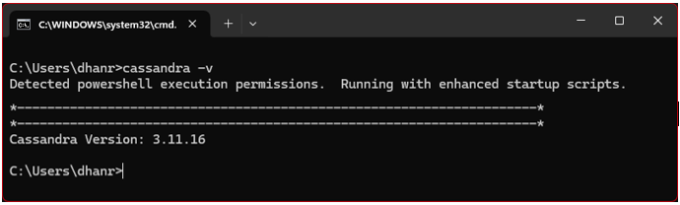

**Start Cassandra Service**

**cassandra**

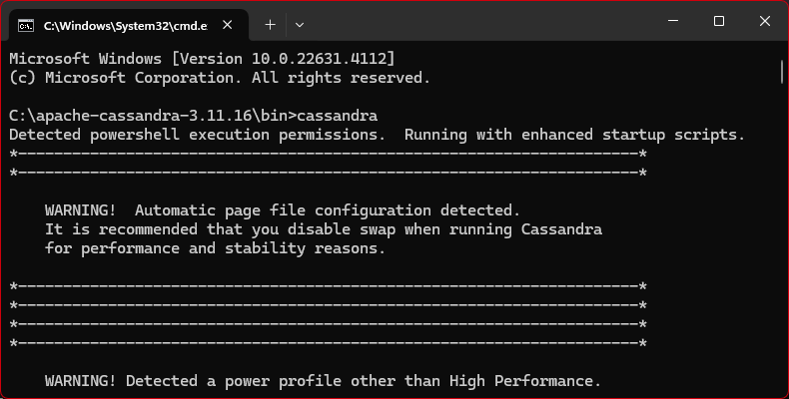

**Launch Cassandra Query Language Shell (CQLSH)**

**cqlsh**

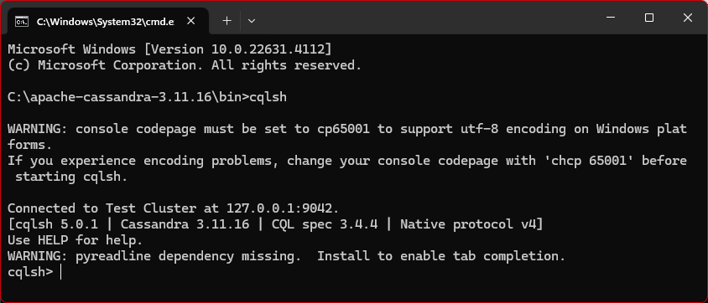

**Provides help and lists available commands in the Cassandra shell.**

**help;**

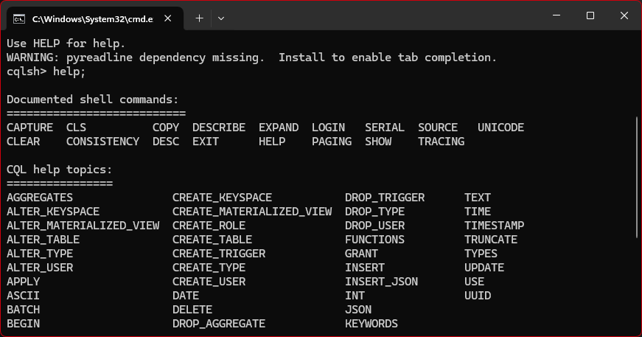

**Displays the connected host.**

**show host;**

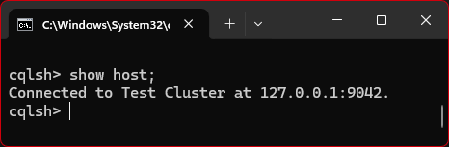

**Displays the version of Cassandra.**

**show version;**

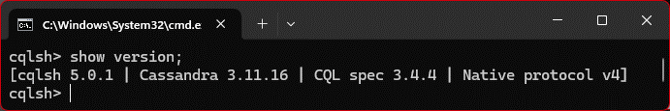

**Shows the current consistency level for reads and writes.**

**consistency;**

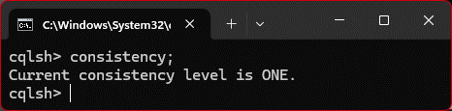

**Provides details about the current cluster configuration.**

**describe cluster;**

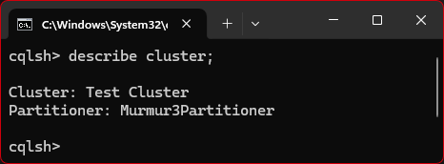

**Create a new Keyspaces**

**CREATE KEYSPACE DhanDB WITH replication = {'class':'SimpleStrategy', 'replication_factor':3};**

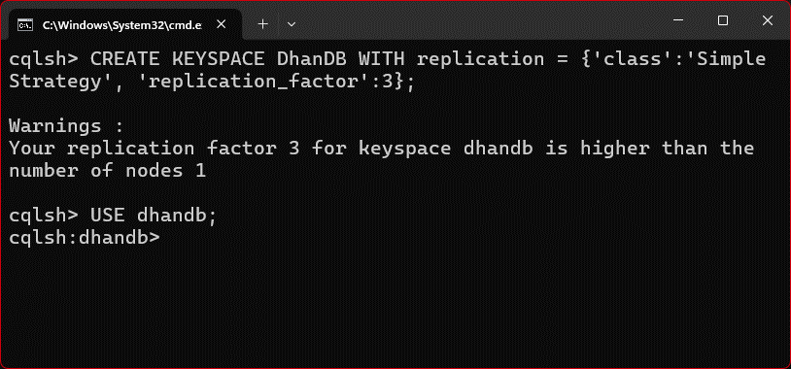

**Use Keyspace: After creating a keyspace, you need to select it to run queries within it:**

**USE dhandb**

**Create Table: You can create tables within your keyspace, for example:**

**CREATE TABLE students{...}**

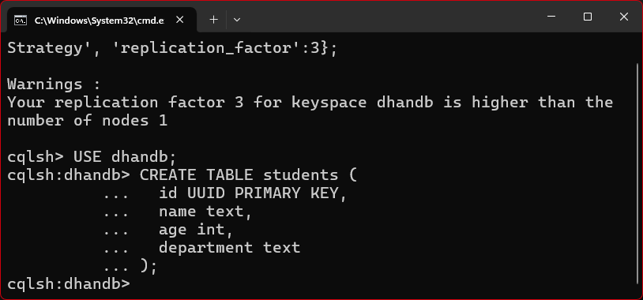

**Insert Data: To insert data into your table:**

**INSERT INTO students (id, name, age, department) VALUES (uuid(), 'Dhanraj Chinta', 22, 'MscIT');**

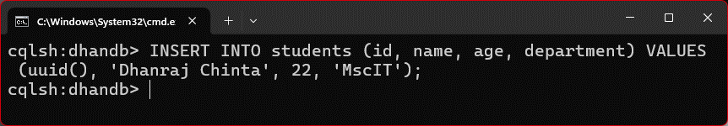

**Select Data: Fetch data from the table:**

**SELECT * FROM students;**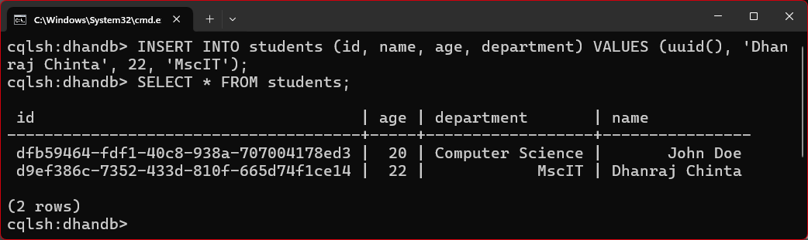

**Shows all the keyspaces in the database.**

**describe keyspaces;**

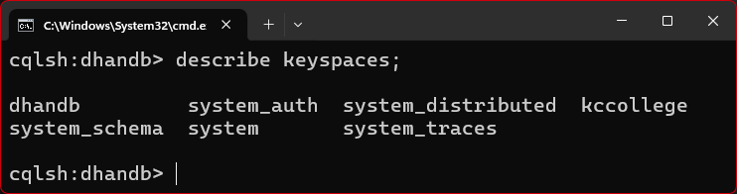

**Lists the tables in the current keyspace (ensure you have a keyspace selected).**

**describe tables;**

